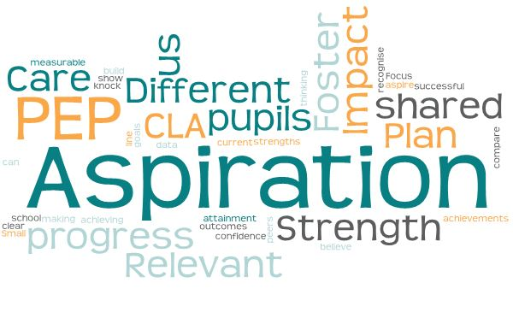
Virtual School Conference 2021
Increasing Aspiration for CLA Pupils

Reflection (Slide 7)
Thinking about the current progress and attainment for CLA pupils in your school how do these data outcomes compare?
Are your CLA pupils achieving in line with their peers?
Are they making clear, measurable progress?
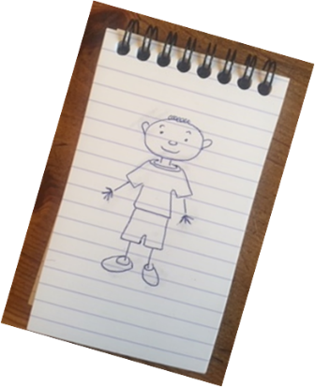

Reflection (Slide 10)
https://afaeducation.org/free-dt-resources/explore-our-resources/10-things-children-looked-after-want-you-to-know
“8. Don’t knock our confidence – show us our strengths so we can build on them, and recognise our achievements, believe in us and aspire for us.”

Questions to ask ourselves:
- How can we show our CYP their strengths?
- How do I recognise achievements?
- How do I aspire for them?

My Aspirations: (Slide 12)
Choose an aspiration and map how you will achieve it, for example:
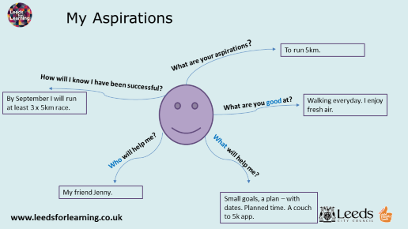

Look at the branches that help with short term goals to achieve the aspiration:
- What is/are your aspirations?
(Be aware that there are achievable aspirations and ‘bigger’ blue sky aspirations. Is 5km really ‘aspirational’ for this person?)

- What are you good at?
(Focus on the strengths of the situation! A focus on what the person can’t do is unhelpful “Well you can’t even run 50 metres, therefore you’re not going to run 5km….”)

- What will help me?
(A chance to outline small goals. Be as specific as you can.)

- Who will help me?

- How will I know I have been successful?

(It could be helpful to set very clear outcomes here, something that is measurable and indicates time.)

Name:

What is important:

Strengths:

(Slide 15)
It may be worth considering aspects of what is done at a whole school level to develop aspirations and promote success and achievement.
Here are a couple of starting points.
What does that look like for a CLA and how do you know it has impact?
What next? (pupil voice all the way)
“Treat us the
same but
differently”
Whole school  Strategies for promoting and developing aspirations or reflecting on aspirations for young people | Same but different or more | Action
Ethos and values

Relationship

Safe environment

Staff training

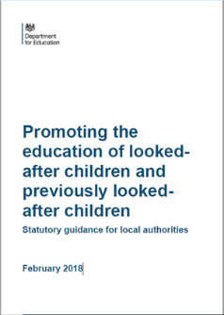
What can schools do? (Slide 19)
- What value is placed on the PEP in your setting?
- How well is it used to capture vital information?

“High aspirations are crucial to successful planning for the future. They should focus on the child or young person’s strengths and capabilities and the outcomes they want to achieve.”

Consider the PEPs that you hold within your setting:
- Do they reflect aspirational targets?
- Do they focus and build on pupil strengths?
- Who contributes to the PEP content?

Self-Audit: How could you improve your PEP?
Rate yourself 1-4:
- 4 being “great, no improvement needed!”
- 1 being “quite dire….. lots of work to be done!”

‘Best’ PEP features | 1 | 2 | 3 | 4
Shared
Used
Updated
Relevant
Age relevant
Have SMART long and short term targets, with actions and time scales.
Aspirational
Distinct from other plans
Backed up with a ‘one page profile’
Features taken from “CLA friendly schools” Merthyr Tydfil
Which ONE feature could you improve with a little effort/ work?

Which ONE feature would you like to improve?

